Citizens Coinage Advisory Committee | C CAC
801 Ninth Street, NW, Washington, DC 20220 | C CAC

March 8, 2010

The Honorable Timothy F. Geithner
Secretary of the Treasury
Department of the Treasury
1500 Pennsylvania Avenue, NW
Washington, D.C. 20220

Dear Secretary Geithner:

A public meeting of the Citizens Coinage Advisory Committee was held on February 23, 2010, at United States Mint Headquarters in Washington, DC. The Committee reviewed proposed narratives for the 2011 issues of the First Spouse Gold Coin and Medal Program, and provided comments and suggestions for consideration by the United States Mint.

Sincerely,

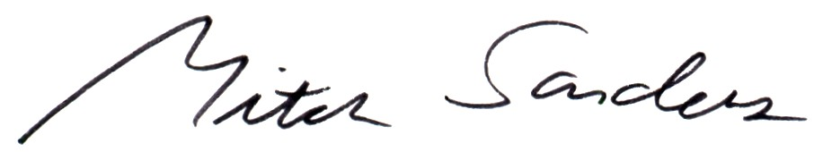

Mitch Sanders
Member Liaison

