Citizens Coinage Advisory Committee | C CAC
801 Ninth Street, NW, Washington, DC 20220 | C CAC

February 18, 2010

The Honorable Timothy F. Geithner
Secretary of the Treasury
Department of the Treasury
1500 Pennsylvania Avenue, NW
Washington, D.C. 20220

Dear Secretary Geithner:

A public meeting of the Citizens Coinage Advisory Committee (Committee) was held on January 26, 2010, at United States Mint Headquarters in Washington, DC. The Committee reviewed proposed reverse designs for the 2011 issues of the America the Beautiful Quarters Program.

For the coin portraying Gettysburg National Military Park in Pennsylvania, several members supported design PA-01, which depicts the 72nd Pennsylvania Infantry Monument. However, several members did not support any of the images presented, and most members would have preferred design concepts related to the Battle of Gettysburg and its vital role in American history. The Committee voted 7-2 to encourage the United States Mint to consider soliciting additional designs, perhaps more symbolic in nature, to convey the importance of Gettysburg National Military Park to our Nation.

For the coin portraying Glacier National Park in Montana, the committee unanimously preferred design MT-03, which portrays a mountain goat over the rocky slopes of the park’s high country. Members were enthusiastic about the combination of an iconic mountain goat with the grandeur of the mountains, and felt that this design would translate into a very appealing coin.

For the coin portraying Olympic National Park in Washington, the Committee unanimously preferred design WA-01, which features a Roosevelt elk with a view of Mount Olympus in the background. Once again, the Committee found the combination of the park’s wildlife and scenery to be especially compelling.

For the coin portraying Vicksburg National Military Park in Mississippi, the Committee strongly favored design MS-02, which carries an image of the U.S.S. Cairo on the Mississippi River as it would have appeared during the Civil War. Members felt that this design, in addition to the quality of its composition, has the virtue of showcasing the historical significance of the Navy in the Civil War.

For the coin portraying Chickasaw National Recreation Area in Oklahoma, the committee preferred design OK-01, which features Buffalo Springs amid its stone spillway. Members generally appreciated the perspective and composition of this design, particularly the foreground foliage. However, some members were concerned that the human figure would be so small as to be indistinct on the small scale of a coin.

Sincerely,

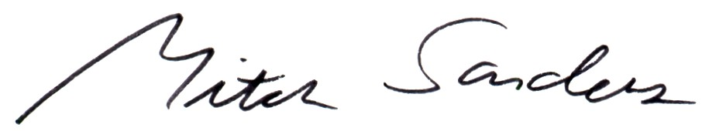

Mitch Sanders
Member Liaison

