Citizens Coinage Advisory Committee | C CAC
801 Ninth Street, NW, Washington, DC 20220 | C CAC

November 20, 2009

The Honorable Timothy F. Geithner
Secretary of the Treasury
Department of the Treasury
1500 Pennsylvania Avenue, NW
Washington, D.C. 20220

Dear Secretary Geithner:

A public meeting of the Citizens Coinage Advisory Committee was held on November 12, 2009, at United States Mint Headquarters in Washington, DC. The Committee reviewed proposed obverse designs for Presidential $1 Coins to be issued in 2011.

For the Andrew Johnson Presidential $1 Coin, the Committee overwhelmingly prefers design 2, for the directness of its portrait.

For the Ulysses S. Grant Presidential $1 Coin, the committee expressed an overwhelming preference for design 1, in appreciation of the realism and ruggedness of the image.

Two designs received significant support for the Rutherford B. Hayes Presidential $1 Coin, with design 5 narrowly preferred over design 1 because of its more closely cropped composition.

For the James Garfield Presidential $1 Coin, the Committee strongly prefers design 5, which was considered to be the most accurate and aesthetically pleasing.

For several of the designs presented, members expressed concern about the portrayal of the President’s hair, moustache, or beard. The Committee therefore recommends that whichever designs are chosen, attention should be given to the accuracy and aesthetic quality of the tonsorial elements of Presidential images.

The Committee also voted unanimously to endorse the proposed theme for the 2011 issue of the Native American $1 Coin Program, “Ousamequin Chief Massasoit of the Wampanoag Welcomes the settlers at Plymouth Bay (1621).”

Sincerely,

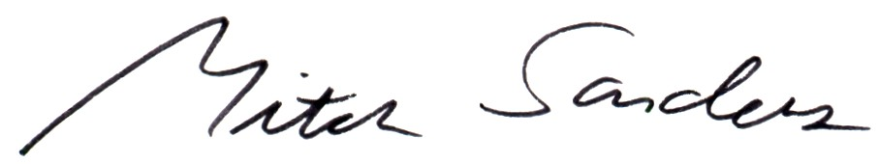

Mitch Sanders
Member Liaison

