Citizens Coinage Advisory Committee | C CAC
801 Ninth Street, NW, Washington, DC 20220 | C CAC

October 26, 2009

The Honorable Timothy F. Geithner
Secretary of the Treasury
Department of the Treasury
1500 Pennsylvania Avenue, NW
Washington, D.C. 20220

Dear Secretary Geithner:

A public meeting of the Citizens Coinage Advisory Committee was held on October 14, 2009, at United States Mint Headquarters in Washington, DC. The Committee reviewed proposed reverse designs for two Congressional Gold Medals, honoring Constantino Brumidi and the Women’s Airforce Service Pilots.

For the obverse of the Constantino Brumidi medal, the Committee preferred design 2. Members appreciated the artistry of the ornate border, and considered the portrait to be a livelier image than the alternatives. For the medal’s reverse, the committee strongly preferred design 2, which features the iconic image of Brumidi’s “Apotheosis of Washington” surrounding the inscription “Artist of the Capitol.” Members were strongly opposed to reverse designs 1 and 3, because of a concern that there was not sufficient historical documentation supporting the quotation attributed to Brumidi.

For the Women’s Airforce Service Pilots medal, the Committee overwhelmingly preferred obverse design 1, featuring a female pilot exiting an airplane after a flight, and reverse design 1, which portrays three aircraft flown by the Women’s Airforce Service Pilots. Members praised the sense of action in the composition of these designs, and found them to be clear and effective representations of the group’s contributions to military aviation.

Sincerely,

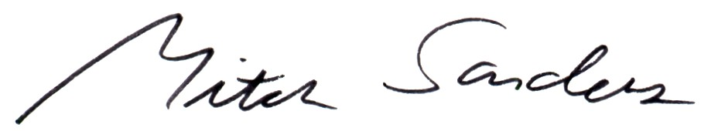

Mitch Sanders
Member Liaison

