Citizens Coinage Advisory Committee | C CAC
801 Ninth Street, NW, Washington, DC 20220 | C CAC

September 30, 2009

The Honorable Timothy F. Geithner
Secretary of the Treasury
Department of the Treasury
1500 Pennsylvania Avenue, NW
Washington, D.C. 20220

Dear Secretary Geithner:

A public meeting of the Citizens Coinage Advisory Committee was held on September 22, 2009, at United States Mint Headquarters in Washington, DC.

The Committee reviewed proposed reverse designs for the 2010 issues of the America the Beautiful Quarters™ program, and recommends the following:

For the coin portraying Hot Springs National Park in Arkansas, the Committee strongly recommends design 4, which shows a focused view of the public fountain in front of the site’s headquarters building. Members appreciated the design’s clear imagery, emphasis on water, and incorporation of natural landscape.

For the coin portraying Yellowstone National Park in Wyoming, the Committee strongly prefers design 1, showing Old Faithful geyser with bison in the foreground and background. Members felt that design 1 would work well on a small coin, and that the depiction of animal life enhanced the design.

For the coin portraying Yosemite National Park in California, the Committee prefers design 3, featuring a view of El Capitan. Members praised the simplicity and ruggedness of the design, and its effective composition.

For the coin portraying Grand Canyon National Park in Arizona, the Committee narrowly prefers design 1, featuring a canyon-level view of the granaries above the Nankoweap Delta, over design 4, which features an aerial view of the canyon. Both were considered to be powerful images, with design 1 preferred for its more immediate, human-scaled view of the canyon.

For the coin portraying Mount Hood National Forest in Oregon, the Committee overwhelmingly prefers design 3, featuring a view of Mount Hood with Lost Lake in the foreground. Design 3 was lauded for the artistry of its imagery, and for the absence of design elements that would detract from the view of the mountain.

The Committee also reviewed proposed obverse and reverse designs for the 2010 issues of the First Spouse Gold Bullion coin program, and recommends the following:

Abigail Fillmore Obverse: Design 3
Abigail Fillmore Reverse: Design 5
Jane Pierce Obverse: Design 1
Jane Pierce Reverse: Design 3
James Buchanan’s Liberty Obverse: Design 1
James Buchanan’s Liberty Reverse: Design 4
Mary Todd Lincoln Obverse: Design 5
Mary Todd Lincoln Reverse: Design 2

Sincerely,

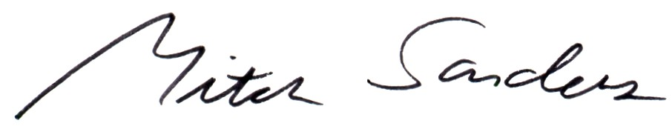

Mitch Sanders
Chair

