Citizens Coinage Advisory Committee | C CAC
801 Ninth Street, NW, Washington, DC 20220 | C CAC

July 8, 2009

The Honorable Timothy F. Geithner
Secretary of the Treasury
Department of the Treasury
1500 Pennsylvania Avenue, NW
Washington, D.C. 20220

Dear Secretary Geithner,

A public meeting of the Citizens Coinage Advisory Committee was held on June 29, 2009, in conjunction with the American Numismatic Association’s Summer Seminar in Colorado Springs, Colorado.

The committee reviewed proposed designs for the medal honoring Edmund C. Moy as 38th Director of the United States Mint. The committee voted unanimously and enthusiastically to recommend the single proposed obverse image, DM-O-01. Opinions were more divided on the medal’s reverse, though nearly all members supported at least one of the proposed designs. The committee recommends that the medal’s reverse should have the image of DM-R-01, with the inscriptions arranged as in DM-R-02, and produced with the sculptural relief of DM-R-03 and DM-R-04.

The committee also considered proposed designs for a 2010 commemorative silver dollar honoring 100 years of the Boy Scouts of America. The committee strongly recommends obverse design BSA-O-08, which shows a 1910 Scout offering a helping hand to a modern scout. Members considered this design to be aesthetically appealing, and appropriately symbolic of the program’s theme. For the reverse design, the committee recommends design BSA-R-04. Members agreed that whichever designs are chosen, the United States Mint should ensure that the details of the images are accurately presented.

Sincerely,

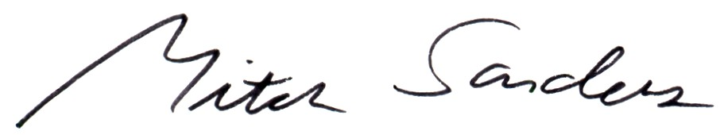

Mitch Sanders
Chair

