Citizens Coinage Advisory Committee | C CAC
801 Ninth Street, NW, Washington, DC 20220 | C CAC

June 12, 2009

The Honorable Timothy F. Geithner
Secretary of the Treasury
Department of the Treasury
1500 Pennsylvania Avenue, NW
Washington, D.C. 20220

Dear Secretary Geithner,

A public meeting of the Citizens Coinage Advisory Committee was held on June 3, 2009 at United States Mint headquarters in Washington, DC.

The committee considered candidate designs for the American Veterans Disabled for Life Commemorative Silver Dollar, to be issued in 2010. The committee voted unanimously to recommend obverse design ADV-O-07, which shows the legs and boots of three veterans, paired with reverse design ADV-R-04, which features military dog tags superimposed in front of a graphic representation of an American flag. Members considered these designs to be symbolically compelling and aesthetically appealing, and felt that the two designs would complement one another in telling the story of America’s disabled veterans.

The committee also evaluated candidate designs for the 2010 First Spouse Gold Coin recognizing James Buchanan’s Presidency. As specified by law, the obverse image will be emblematic of the concept of liberty as represented on a United States coin issued during President Buchanan’s term in office. The committee recommends either an image based on the obverse of the Liberty Head $2.50 coin issued from 1860 to 1907, or an image based on the obverse of the Flying-Eagle cent issued in 1857 and 1858.

Sincerely,

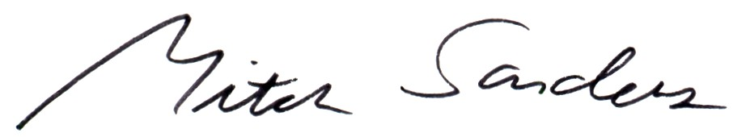

Mitch Sanders
Chair

