Citizens Coinage Advisory Committee | C CAC
801 Ninth Street, NW, Washington, DC 20220 | C CAC

May 5, 2009

The Honorable Timothy F. Geithner
Secretary of the Treasury
Department of the Treasury
1500 Pennsylvania Avenue, NW
Washington, D.C. 20220

Dear Secretary Geithner,

A public meeting of the Citizens Coinage Advisory Committee was held on April 28, 2009 at United States Mint headquarters in Washington, DC.

The committee considered candidate designs for the reverse of the Lincoln Cent. According to Public Law 109-145, the design on the reverse of one-cent coins issued after December 31, 2009 shall bear an image emblematic of President Lincoln’s preservation of the United States as a single and united country.

The committee recommends design LP-13, which features a Union shield. Committee members considered the shield to be a classic symbol from the Civil War era, and appropriately emblematic of Lincoln’s preservation of the Union. Design LP-13 was preferred over other shield-based designs due to its focus on a single design element, which members felt would promote clarity on a small coin.

Designs featuring the United States Capitol were generally considered to have only a tenuous relationship to the coin’s theme, and attracted little support. Of the Capitol designs, LP-02 was preferred due to its visual simplicity. However, this design received considerably less support than the committee’s first choice, LP-13, and was also ranked behind the committee’s second choice, LP-17, which features a naturalistic eagle.

The committee also considered candidate designs for the reverse of the 2010 issue of the Native American $1 coin program, with the theme of “Government.” The CCAC recommends design NA-05, depicting a wampum belt with five arrows bundled together. This image was the clear and unanimous choice of committee members, who considered it to be both historically meaningful and visually compelling.

Sincerely,

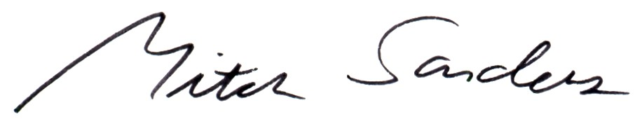

Mitch Sanders
Chair

