Citizens Coinage Advisory Committee | C CAC
801 Ninth Street, NW, Washington, DC 20220 | C CAC

March 3, 2009

The Honorable Timothy F. Geithner
Secretary of the Treasury
Department of the Treasury
1500 Pennsylvania Avenue, NW
Washington, D.C. 20220

Dear Secretary Geithner:

A public meeting of the Citizens Coinage Advisory Committee (CCAC) was held on February 24, 2009, at the United States Mint headquarters in Washington, D.C.

The CCAC considered proposed designs for the Congressional Gold Medal honoring former Senator Edward William Brooke III. The CCAC voted 7-1 to recommend the proposed designs, with two members abstaining.

The CCAC also considered proposed designs for the Congressional Gold Medal honoring Daw Aung San Suu Kyi of Burma. The CCAC voted 7-1 to recommend the proposed designs, with two members abstaining.

The CCAC examined reverse design narratives for the 2010 First Spouse Gold Coins honoring Abigail Fillmore, Jane Pierce, James Buchanan’s Liberty, and Mary Todd Lincoln. There was no objection to any of the narratives presented.

Sincerely,

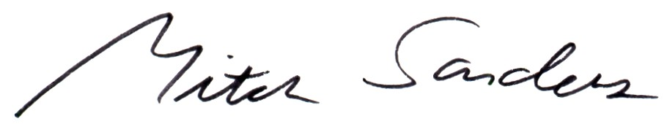

Mitch Sanders
Chair

