Citizens Coinage Advisory Committee | C CAC
801 Ninth Street, NW, Washington, DC 20220 | C CAC

February 3, 2009

The Honorable Timothy F. Geithner
Secretary of the Treasury
Department of the Treasury
1500 Pennsylvania Avenue, NW
Washington, D.C. 20220

Dear Secretary Geithner,

A public meeting of the Citizens Coinage Advisory Committee was held on January 27, 2009 at United States Mint headquarters in Washington, DC.

The committee considered proposed obverse images for the 2010 issues of the Presidential $1 coin program. The CCAC recommends the following designs:

Millard Fillmore: 13-01
Franklin Pierce: 14-01
James Buchanan: 15-02
Abraham Lincoln: 16-03

Committee members generally felt that design 16-03, based on an 1865 photograph by Alexander Gardner, was an excellent portrayal of Lincoln as President.

Sincerely,

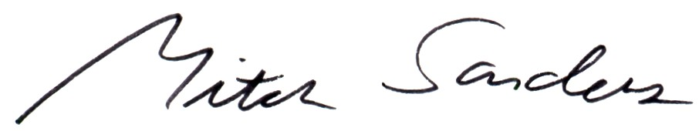

Mitch Sanders
Chair

