Citizens Coinage Advisory Committee | C CAC
801 Ninth Street, NW, Washington, DC 20220 | C CAC

December 26, 2008

The Honorable Henry M. Paulson, Jr.
Secretary of the Treasury
Department of the Treasury
1500 Pennsylvania Avenue, NW
Washington, D.C. 20220

Dear Secretary Paulson,

A public meeting of the Citizens Coinage Advisory Committee was held on November 24, 2008 in West Point, NY.

The committee considered proposed designs for several medals to be produced by the United States Mint.

For the Congressional Gold Medal honoring former Prime Minister Tony Blair of the United Kingdom, the CCAC recommends the obverse and reverse designs proposed by the United States Mint.

For the medal honoring Henry M. Paulson, Jr., 74th Secretary of the Treasury, the CCAC recommends the obverse and reverse designs proposed by the United States Mint.

For the medal honoring Edmund C. Moy, 38th Director of the United States Mint, the CCAC recommends obverse design DM-O-01A and reverse design DM-R-03.

The committee also reviewed the United States Mint’s proposed narratives for the 2010 issue of the Native American $1 Coin Program, and offered comments and suggestions related to the historical accuracy of the materials presented.

Sincerely,

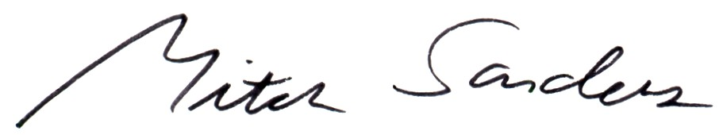

Mitch Sanders
Chair

