Citizens Coinage Advisory Committee | C CAC
801 Ninth Street, NW, Washington, DC 20220 | C CAC

October 1, 2008

The Honorable Henry M. Paulson, Jr.
Secretary of the Treasury
Department of the Treasury
1500 Pennsylvania Avenue, NW
Washington, D.C. 20220

Dear Secretary Paulson,

A public meeting of the Citizens Coinage Advisory Committee was held on September 24, 2008, at United States Mint Headquarters in Washington, DC.

The committee evaluated proposed designs for the United States Mint medal honoring President George W. Bush’s second term. Members appreciated the boldness and artistry of the proposed designs, and voted unanimously to recommend them.

Sincerely,

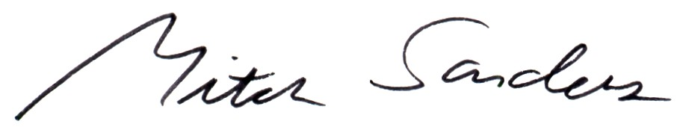

Mitch Sanders
Chair

Enclosure

