Citizens Coinage Advisory Committee | C CAC
801 Ninth Street, NW, Washington, DC 20220 | C CAC

August 13, 2008

The Honorable Henry M. Paulson, Jr.
Secretary of the Treasury
Department of the Treasury
1500 Pennsylvania Avenue, NW
Washington, D.C. 20220

Dear Secretary Paulson,

A public meeting of the Citizens Coinage Advisory Committee was held on August 1, 2008, in conjunction with the annual convention of the American Numismatic Association in Baltimore, MD.

The committee evaluated proposed designs for the 2009 issue of the American Eagle Platinum Coin Program. As part of a six-year series exploring the core concepts of American democracy, expressed in the preamble to the United States Constitution, the theme for the 2009 issue is “to form a more perfect union.”

The CCAC recommends design AEP-R-07, which features the diversity of America represented by four faces, along with the inscription “A MORE PERFECT UNION.” Members appreciated the artistry, creativity, and symbolism of this design.

The CCAC also recommends image C for the series’ privy mark.

Sincerely,

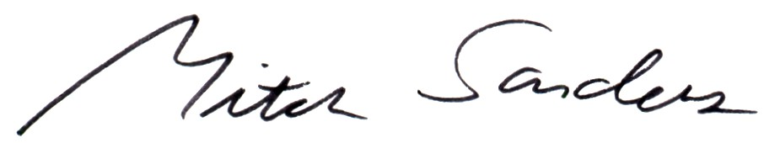

Mitch Sanders
Chair

