Citizens Coinage Advisory Committee | C CAC
801 Ninth Street, NW, Washington, DC 20220 | C CAC

June 30, 2008

The Honorable Henry M. Paulson, Jr.
Secretary of the Treasury
Department of the Treasury
1500 Pennsylvania Avenue, NW
Washington, D.C. 20220

Dear Secretary Paulson,

A public meeting of the Citizens Coinage Advisory Committee was held on June 18, 2008 at United States Mint Headquarters in Washington, DC. The committee evaluated proposed designs for the 2009 issue of the Native American $1 Coin Program. Under this program, each year a circulating dollar coin will be issued with a reverse design emblematic of a historical contribution made by an Indian tribe or an individual Native American.

Obverse Design

For the coin’s obverse the CCAC recommends the design proposed by the United States Mint, which features the same design as the Sacagawea dollar issued from 2000 to 2008.

Reverse Design

The coins’ reverse design represents “Three Sisters” symbiotic agriculture, introduced circa 1000 A.D. The CCAC recommends design NA-12, which portrays a Native American woman planting seeds, along with three mounds of beans, corn, and squash. Members generally appreciated the artistry of this design and its recognition of women’s role in agriculture, and considered it to be a clear representation of the coin’s agricultural theme. There was also substantial support for design NA-15, which features three allegorical Native American female faces interspersed with agricultural images. Members considered this to be an artistically appealing and innovative design, but were concerned that the meaning of the image would not be clear.

Edge Design

For the coin’s edge design, the CCAC recommends the template proposed by the United States Mint, which presents the coin’s date and mintmark, and the inscription E PLURIBUS UNUM, separated by stars.

Sincerely,

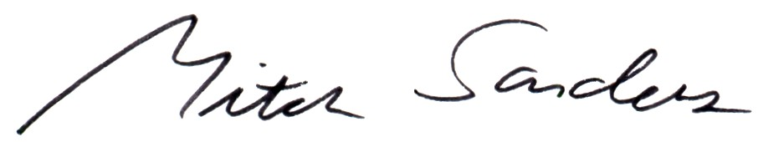

Mitch Sanders
Chair

