Citizens Coinage Advisory Committee | C CAC
801 Ninth Street, NW, Washington, DC 20220 | C CAC

June 3, 2008

The Honorable Henry M. Paulson, Jr.
Secretary of the Treasury
Department of the Treasury
1500 Pennsylvania Avenue, NW
Washington, D.C. 20220

Dear Secretary Paulson,

A public meeting of the Citizens Coinage Advisory Committee was held on May 20, 2008 at United States Mint Headquarters in Washington, DC. The committee evaluated proposed reverse designs for 2009 circulating commemorative quarter-dollar coins honoring the District of Columbia, the Commonwealth of Puerto Rico, Guam, American Samoa, the U.S. Virgin Islands, and the Commonwealth of the Northern Mariana Islands.

The CCAC recommends the following designs:

District of Columbia: DC-02, featuring Benjamin Banneker peering through a surveyor’s transit, is the committee’s recommendation. The committee further recommends that the position of the inscriptions “JUSTICE FOR ALL” and “BENJAMIN BANNEKER” should be reversed, so that Banneker’s name appears below his image.

Commonwealth of Puerto Rico: Design PR-02, featuring an historic sentry box and a hibiscus flower, was strongly preferred by the committee.

Guam: Design GU-02, featuring a flying proa sailing, was strongly preferred by the committee.

American Samoa: The CCAC recommends design AS-01, featuring a tattoed Samoan man holding an ava cup. The committee also recommends that the motto “SAMOA MUAMUA LE ATUA” (Samoa, Let God Be First) should be incorporated into the design.

U.S. Virgin Islands: Design VI-03 was narrowly preferred by the committee.

Commonwealth of the Northern Mariana Islands: Design NMI-02, featuring a large stone pillar, with a Carolinian canoe under sail in the background, was strongly preferred by the committee.

The CCAC also reviewed a revised version of the design previously recommended for the reverse of the Anna Harrison First Spouse coin and medal (design AH-R-02),.and recommends that this modified version should be issued.

Sincerely,

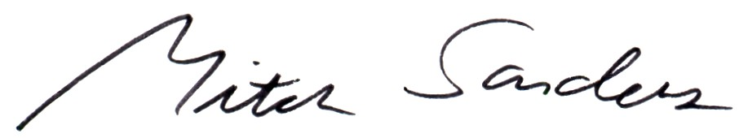

Mitch Sanders
Chair

