Citizens Coinage Advisory Committee | C CAC
801 Ninth Street, NW, Washington, DC 20220 | C CAC

July 25, 2008

The Honorable Henry M. Paulson, Jr.
Secretary of the Treasury
Department of the Treasury
1500 Pennsylvania Avenue, NW
Washington, D.C. 20220

Dear Secretary Paulson,

A public meeting of the Citizens Coinage Advisory Committee was held on April 22, 2008 at United States Mint Headquarters in Washington, DC.

2009 First Spouse Gold Coins and Bronze Medals

The committee evaluated proposed obverse and reverse designs for the First Spouse gold coins and bronze medals to be issued by the United States Mint in 2009. The obverse will feature a likeness of the First Spouse, and the reverse will bear an image emblematic of the life and work of the First Spouse.

For the coin and medal obverses, the CCAC recommends:

Anna Harrison: Design AH-O-02
Letitia Tyler: Design LT-O-04
Julia Tyler: Design JT-O-03
Sarah Polk: Design SP-O-05
Margaret Taylor: Design MT-O-01

For the coin and medal reverses, the CCAC recommends:

Anna Harrison: Design AH-R-02, featuring Mrs. Harrison teaching students from her school
Letitia Tyler: Design LT-R-03, featuring Mrs. Tyler on the back porch of a Cedar Grove plantation
Julia Tyler: Design JT-R-01, featuring President Tyler handing a gold pen to Mrs. Tyler in appreciation of her support during his signing of the Treaty of Annexation with Texas; or
Design JT-R-04, depicting President and Mrs. Tyler dancing at a White House Ball
Sarah Polk: Design SP-R-01, featuring Mrs. Polk working as a secretary in
The White House in support of her husband’s political career
Margaret Taylor: Design MT-R-01, featuring Mrs. Taylor helping an injured
soldier during the Seminole War.

2009 Native American $1 Circulating Coin

The committee also reviewed a proposed narrative, “Agriculture – Spread of Three Sisters,” for the 2009 issue of the Native American $1 Coin. This theme was enthusiastically supported by the committee.

Sincerely,

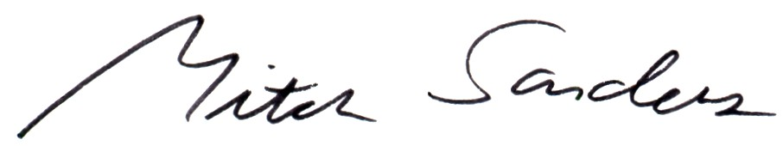
Mitch Sanders
Chair

