Citizens Coinage Advisory Committee | C CAC
801 Ninth Street, NW, Washington, DC 20220 | C CAC

March 26, 2008

The Honorable Henry M. Paulson, Jr.
Secretary of the Treasury
Department of the Treasury
1500 Pennsylvania Avenue, NW
Washington, D.C. 20220

Dear Secretary Paulson,

A public meeting of the Citizens Coinage Advisory Committee was held on March 13, 2008 at United States Mint Headquarters in Washington, DC. The committee evaluated proposed designs for the following upcoming issues of the United States Mint.

2009 Ultra High Relief 24-Karat Gold Coin

The CCAC voted unanimously and enthusiastically to endorse the United States Mint’s plan for a 2009-dated gold coin, 27 millimeters in diameter, reproducing the image of the experimental Ultra-High relief $20 coin created by Augustus Saint-Gaudens in 1907. The committee also voted to recommend that the original design should be slightly modified to include 50 stars on the obverse, instead of 46 stars (representing the number of states in the Union at the time) on the original.

2009 Lincoln Cent

For the 2009 circulating cent representing Abraham Lincoln’s Presidency, the CCAC recommends design LC-R4-04, featuring a standing image of Lincoln before the completed Capitol. Members considered this design to present a clear and meaningful image, with a combination of elements that would work reasonably well in the context of a small coin. Members of the committee expressed concern that the image of the uncompleted Capitol Dome on designs LC-R4-01 and LC-R4-03 would not present an understandable symbolism.
The CCAC also recommends that for the one-cent coins issued in 2009, the designer’s initials VDB on Lincoln’s shoulder should be emboldened.

2009 Louis Braille Bicentennial-Braille Literacy Commemorative Silver Dollar

For the 2009 Louis Braille Bicentennial-Braille Literacy Commemorative Silver Dollar, the CCAC recommends obverse design BC-O-03 and reverse design BC-R-05. Members felt that the portrait of Braille obverse BC-O-03 conveys his intelligence, confidence, and energy. The committee also appreciated the quality of the artwork on reverse BC-R-05, especially the

expression on the child’s face and the incorporation of the words “LITERACY” and “INDEPENDENCE.”

Sincerely,

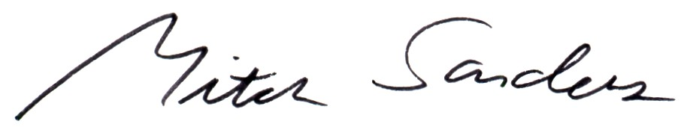

Mitch Sanders
Chair

