Citizens Coinage Advisory Committee | C CAC
801 Ninth Street, NW, Washington, DC 20220 | C CAC

January 29, 2008

The Honorable Henry M. Paulson, Jr.
Secretary of the Treasury
Department of the Treasury
1500 Pennsylvania Avenue, NW
Washington, D.C. 20220

Dear Secretary Paulson,

A public meeting of the Citizens Coinage Advisory Committee was held on January 15, 2008, at United States Mint Headquarters in Washington, DC. The committee evaluated proposed designs for the following upcoming issues of the United States Mint.

Congressional Gold Medal for Michael Ellis DeBakey, M.D.

The CCAC recommends the proposed obverse design, which portrays Dr. DeBakey, and the proposed reverse design, which features an anatomical heart encircled by an inscribed ribbon. The committee also endorses any changes suggested by Dr. DeBakey regarding the anatomical appearance of the heart on the reverse.

2009 Lincoln Cent

For the 2009 circulating cent representing Abraham Lincoln’s Presidency, the CCAC recommends a modified version of design LC-R4-11, which features a Civil War cannon. Specifically, the committee recommends that the standing figure of Lincoln, which would be indistinct on a small coin, should be removed. The committee further suggests that “E PLURIBUS UNUM” should be placed below the cannon, and that “THE UNION PRESERVED” should appear above the cannon. In the opinion of the CCAC, this design would clearly convey the importance of Lincoln’s wartime presidency.

Of the choices presented to the committee, the CCAC’s preference is for design LC-R4-11. This was strongly preferred over the committee’s second choice, design LC-R4-14.

2009 Presidential $1 Coins

For the 2009 Presidential Dollars, the CCAC recommends the following designs:

William Henry Harrison: WH-03
John Tyler: JT-01
James K. Polk: JP-06
Zachary Taylor: ZT-04

Presidential Dollar Design Templates

For the lettered edge of the Presidential Dollar, the CCAC recommends the proposed arrangement:  2009 P  E PLURIBUS UNUM

The CCAC recommends that the motto IN GOD WE TRUST should be placed on the reverse of the Presidential dollar. Committee members felt that placing the motto on the reverse would have the important benefit of preserving the continuity of the obverse template used for the Presidential dollar series.

Sincerely,

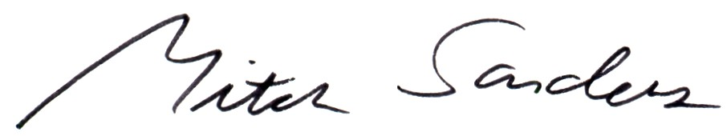

Mitch Sanders
Chair

