Citizens Coinage Advisory Committee | C CAC
801 Ninth Street, NW, Washington, DC 20220 | C CAC

December 10, 2007

The Honorable Henry M. Paulson, Jr.
Secretary of the Treasury
Department of the Treasury
1500 Pennsylvania Avenue, N.W.
Washington, D.C. 20220

Dear Secretary Paulson,

A public meeting of the Citizens Coinage Advisory Committee was held on November 13, 2007, at United States Mint Headquarters in Washington, DC. The committee considered proposed designs for the Abraham Lincoln Bicentennial Commemorative Coin Program, which specifies that during the year 2009 the United States Mint will issue $1 silver coins emblematic of the life and legacy of President Abraham Lincoln.

For the coin’s obverse, the CCAC recommends design LCO-O-06, which features a forward-facing image of Lincoln based on an 1865 photograph. Members generally considered this design to be a powerful and evocative image of Lincoln. The committee’s second choice was design LCO-O-04, featuring an upward view of the statue of Lincoln located in the Lincoln Memorial.

For the coin’s reverse, the CCAC recommends design LCO-R-09, which features an extended quotation from Lincoln’s Gettysburg Address along with allegorical figures from the Soldiers Monument at Gettysburg. Members appreciated this design’s combination of an inspiring message with appealing artwork. The committee’s second choice, design LCO-R-02, features the same quotation, along with Lincoln’s signature.

Sincerely,

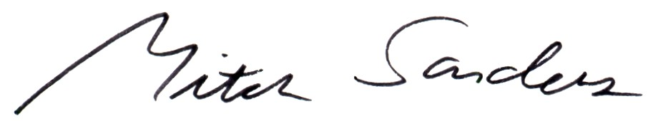

Mitch Sanders
Chair

