Citizens Coinage Advisory Committee | C CAC
801 Ninth Street, NW, Washington, DC 20220 | C CAC

October 15, 2007

The Honorable Henry M. Paulson, Jr.
Secretary of the Treasury
Department of the Treasury
1500 Pennsylvania Avenue, N.W.
Washington, D.C. 20220

Dear Secretary Paulson,

A public meeting of the Citizens Coinage Advisory Committee was held on September 25, 2007, at United States Mint Headquarters in Washington, DC.
The committee reviewed proposed designs for the Abraham Lincoln Bicentennial One-Cent Coin Redesign Program. During the year 2009, the United States Mint will issue four one-cent coins with reverses representing different aspects of the life of Abraham Lincoln. The obverse design will continue to bear the current likeness of Lincoln by Victor David Brenner.

Aspect 1: Lincoln’s Birth in Kentucky (1809-1815)

The CCAC recommends either design LC-R-1-02 or design LC-R-1-05, both of which feature a log cabin, symbolic of Lincoln’s humble beginnings. Committee members generally felt that the unadorned image of the log cabin on these designs would work well on a small coin like the cent.

Aspect 2: Lincoln’s Formative Years in Indiana (1816-1830)

The CCAC recommends design LC-R-2-06. This design was strongly preferred by the committee, with significantly more support than the committee’s second choice, design LC-R-2-07. Both of these designs depict Lincoln improving himself through reading and self-education. Committee members appreciated the quality of the imagery on design LC-R-2-06, and felt that self-education was a highly appropriate theme.

Aspect 3: Lincoln’s Professional Life in Illinois (1831-1861)

Design LC-R-3-08 is the CCAC’s recommendation, and was narrowly preferred over design LC-R-3-06. For this aspect, most of the designs receiving significant support from the committee presented Lincoln as a circuit lawyer, honing his oratorical skills.

Aspect 4: Lincoln’s Presidency in Washington, DC (1861-1865)

The CCAC does not recommend any of the designs presented for Lincoln’s Presidency. Regarding the designs featuring the half-finished Capitol Dome, members generally felt that the connection between the image and Lincoln’s Presidency would not be clear. The committee voted 9-1 to respectfully request reconsideration of the concepts and designs for the design
portraying Lincoln’s Presidency. The committee then voted 8-2 to recommend that new designs should depict Lincoln as war President.

Sincerely,

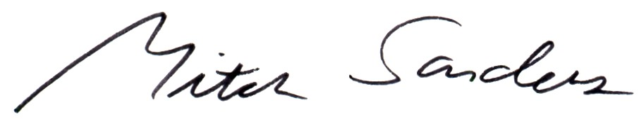

Mitch Sanders
Chair

