Citizens Coinage Advisory Committee | C CAC
801 Ninth Street, NW, Washington, DC 20220 | C CAC

May 22, 2007

The Honorable Henry M. Paulson, Jr.
Secretary of the Treasury
Department of the Treasury
1500 Pennsylvania Avenue, N.W.
Washington, D.C. 20220

Dear Secretary Paulson,

A public meeting of the Citizens Coinage Advisory Committee was held on May 15, 2007, in Philadelphia, PA.

Congressional Gold Medal Honoring Tenzin Gyatso, the Fourteenth Dalia Lama of Tibet

The committee voted unanimously to recommend the proposed obverse and reverse designs for the Congressional Gold Medal honoring Tenzin Gyatso, the Fourteenth Dalai Lama of Tibet. Members were favorably impressed with the artistic quality of the designs.

2008 American Bald Eagle Recovery and National Emblem Commemorative Coin Designs

The committee considered proposed designs for the American Bald Eagle Recovery and National Emblem commemorative coin program. As part of this program, the United States Mint will mint and issue gold, silver, and clad coins emblematic of the bald eagle and its history, natural biology, and national symbolism.

The CCAC’s recommended designs are:

Gold $5 Obverse: BE-O-G-03 (with the date moved to the bottom of the obverse, and incused)
Gold $5 Reverse: BE-R-G-01
Silver $1 Obverse: BE-O-S-08
Silver $1 Reverse: BE-R-S-01. This was the only design presented. The committee subsequently
voted 6-3 to recommend that consideration should be given to substituting an alternative design for the reverse of the silver dollar.
Clad Half Dollar Obverse: BE-O-C-02
Clad Half Dollar Reverse: BE-R-C-02

Sincerely,

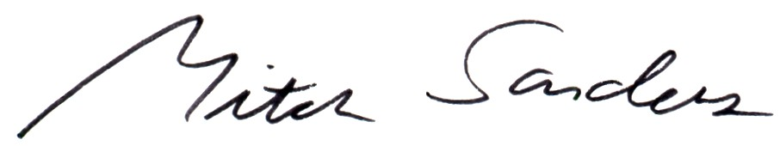

Mitch Sanders
Chair

