Citizens Coinage Advisory Committee | C CAC
801 Ninth Street, NW, Washington, DC 20220 | C CAC

April 10, 2007

The Honorable Henry M. Paulson, Jr.
Secretary of the Treasury
Department of the Treasury
1500 Pennsylvania Avenue, N.W.
Washington, D.C. 20220

Dear Secretary Paulson:

A public meeting of the Citizens Coinage Advisory Committee (CCAC) was held on March 20, 2007, at United States Mint Headquarters in Washington, D.C.

2008 First Spouse Gold Bullion Coins and Bronze Medals
The CCAC considered proposed designs for the 2008 First Spouse gold bullion coins and bronze medals. Under Public Law 109-145, the United States Mint will design and issue $10 coins and bronze medals emblematic of the spouse of each President. The obverse of each coin will bear an image of the First Spouse, with the reverse depicting an image emblematic of the First Spouse’s life and work. For Presidents who served in office without a spouse, the obverse will carry an image emblematic of the concept of Liberty as represented on a coin issued during that President’s term, with a reverse design emblematic of the President’s life and work.

For obverse designs, the CCAC recommends:

Elizabeth Monroe: EM-O-07
Louisa Adams LA-O-06
Andrew Jackson’s presidency LAJ-O-03, Capped Bust of Liberty
Martin Van Buren’s presidency LVB-O-05, Seated Liberty

For reverse designs, the CCAC recommends:

Elizabeth Monroe: EM-R-02 or EM-R-03, both depicting the reopening of the White House
Louisa Adams: LA-R-01, depicting Adams as poet, writer, and musician
Andrew Jackson: LAJ-R-08, depicting Jackson on horseback with the inscription “Old Hickory”
Martin Van Buren: LVB-R-05, depicting Van Buren as President

Congressional Gold Medal Honoring Dr. Norman Borlaug
The CCAC also recommends the proposed obverse and reverse designs for the Congressional Gold Medal honoring Dr. Norman E. Borlaug.

Sincerely,

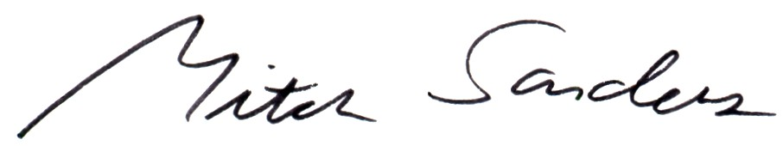

Mitch Sanders
Chair

Enclosures

