Citizens Coinage Advisory Committee | CCAC
801 Ninth Street, NW, Washington, DC 20220 | CCAC

February 6, 2007

The Honorable Henry M. Paulson, Jr.
Secretary of the Treasury
Department of the Treasury
1500 Pennsylvania Avenue, N.W.
Washington, D.C. 20220

Dear Secretary Paulson,

A public meeting of the Citizens Coinage Advisory Committee was held on January 23, 2007, at United States Mint headquarters in Washington, DC.

The committee considered proposed designs for the Oklahoma, New Mexico, Arizona, Alaska, and Hawaii state quarters. These coins will be released in the year 2008.

For Oklahoma the CCAC recommends design OK-5, which was the clear preference of the committee. This design features a traditional calumet and a rendering inspired by the Pioneer Woman Statue, with the three-dimensional shape of the state in the background. Members considered this design to be appropriately symbolic of the state, without being excessively cluttered.

The CCAC recommends design NM-3 for New Mexico’s quarter. This design features the Zia sun symbol superimposed on a topographical map of the state. While committee members generally did not express enthusiasm for any of the proposed New Mexico designs, the topographical representation of the state was considered to be an appealing feature.

Design AZ-1, with a detailed view of the Grand Canyon, is the CCAC’s recommendation for Arizona’s quarter. This design was the clear preference of the committee, and members appreciated both its visual appeal and its thematic consistency.

The CCAC’s recommendation for Alaska’s quarter is design AK-1, which features a polar bear. While committee members commented on the quality and diversity of Alaska’s submissions, the committee was particularly impressed by the simplicity and power of design AK-1.

For Hawaii, the CCAC recommends design HI-3, which portrays Diamond Head along with a statue of King Kamehameha I. This design, which was the clear preference of the committee, received praise for its blend of geography and history, and its use of recognizable symbols in a balanced composition.

The committee also reviewed proposed designs for the Byron Nelson Congressional Gold Medal. The committee voted unanimously to recommend the proposed obverse and reverse designs, with compliments to the Mint for a job well-done.

Sincerely,

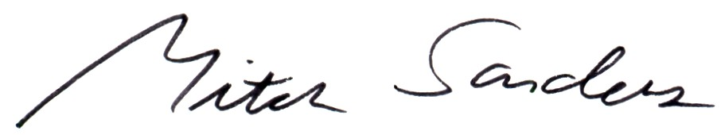

Mitch Sanders
Chair

