Citizens Coinage Advisory Committee | CCAC
801 Ninth Street, NW, Washington, DC 20220 | CCAC

December 1, 2006

The Honorable Henry M. Paulson, Jr.
Secretary of the Treasury
Department of the Treasury
1500 Pennsylvania Avenue, N.W.
Washington, D.C. 20220

Dear Secretary Paulson,

A public meeting of the Citizens Coinage Advisory Committee was held on November 14, 2006.

The CCAC reviewed proposed designs for the 2008 issues of the Presidential Dollar Coin Program. The committee’s recommended designs are:

James Monroe: JM-03
John Quincy Adams: JQA-01
Andrew Jackson: AJ-09
Martin Van Buren: MVB-10

The CCAC also recommends the proposed Indian/Buffalo theme and designs for the 2007 fractional issues of the Mint’s 24-Karat gold proof coin program in addition to the 24-Karat gold uncirculated coin program in all sizes.

The CCAC voted unanimously to report that its second choice for the 2008 American Eagle Platinum Proof bullion coins, representing the Judicial branch of government, had been design J-6. Further, the CCAC had recommended that whichever design was chosen, the figure of Justice should be blindfolded.

Sincerely,

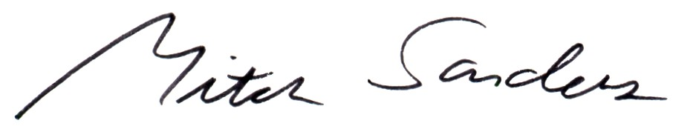

Mitch Sanders
Chair

