Citizens Coinage Advisory Committee | CCAC

October 10, 2006

The Honorable Henry M. Paulson, Jr.
Secretary of the Treasury
Department of the Treasury
1500 Pennsylvania Avenue, N.W.
Washington, D.C. 20220

Dear Secretary Paulson,

A public meeting of the Citizens Coinage Advisory Committee was held on September 28, 2006, via teleconference. Attending the meeting were John Alexander, Leon Billings, Bill Fivaz, Ute Wartenberg Kagan, Rita Laws, Mitch Sanders, Donald Scarinci, Ken Thomasma, and Joe Winter.

The committee considered proposed designs for the Congressional Gold Medal honoring the Tuskegee Airmen. The CCAC recommends the proposed design for the obverse of the medal, which was widely praised by committee members. For the reverse, the committee recommends that the inscription at the bottom of the design should be modified. The CCAC’s recommended wording is “Outstanding Combat Record Contributed to Integration of the Military.”

Sincerely,

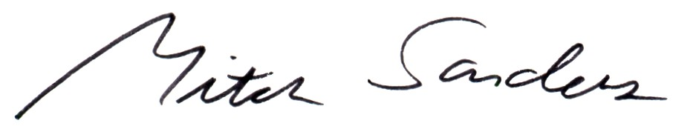

Mitch Sanders
Chair

