Citizens Coinage Advisory Committee | CCAC
801 Ninth Street, NW, Washington, DC 20220 | CCAC

September 5, 2006

The Honorable Henry M. Paulson, Jr.
Secretary of the Treasury
Department of the Treasury
1500 Pennsylvania Avenue, N.W.
Washington, D.C. 20220

Dear Secretary Paulson,

A public meeting of the Citizens Coinage Advisory Committee (CCAC) was held on August 18, 2006, at the Colorado Convention Center in Denver, CO. Attending the meeting were CCAC members John Alexander, Leon Billings (via phone), Bill Fivaz, Rita Laws, Mitch Sanders, Donald Scarinci, Ken Thomasma, and Joe Winter (via phone).

The CCAC was established in 2003 by Congress to advise the Secretary of the Treasury on the themes and designs of all United States coins and medals. The CCAC serves as an informed, experienced and impartial resource to the Secretary and represents the interests of American citizens and collectors in our Nation’s coinage.

The Committee considered proposed designs for the Little Rock Central High School Desegregation 50th Anniversary Commemorative Program. Under this program, the United States Mint will issue up to 500,000 silver dollar coins. For the coin’s obverse, the CCAC recommends design LR-O-04, featuring a group of children walking to school with the protection of a soldier. Members considered this design to be a very appropriate representation of the event being commemorated. The Committee further recommends that the obverse inscription above the date should be changed to “Desegregation in Education.” For the reverse, the committee recommends design LR-R-02.

The Committee also recommends the proposed designs for the obverse and reverse of the bronze medal honoring former Secretary of the Treasury John W. Snow.

Enclosures

Sincerely,

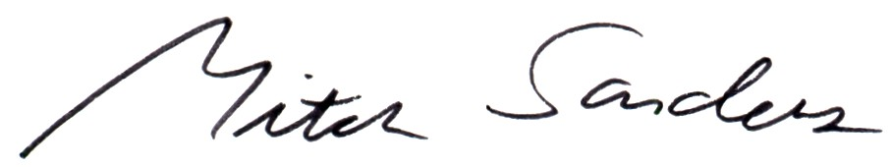

Mitch Sanders
Chair

