Citizens Coinage Advisory Committee | CCAC
801 Ninth Street, NW, Washington, DC 20220 | CCAC

July 14, 2006

The Honorable Henry M. Paulson, Jr.
Secretary of the Treasury
Department of the Treasury
1500 Pennsylvania Avenue, NW
Washington, D.C. 20220

Dear Secretary Paulson,

A public meeting of the Citizens Coinage Advisory Committee was held via teleconference on July 10, 2006. Attending the meeting were John Alexander, Leon Billings, Bill Fivaz, Ute Wartenberg Kagan, Rita Laws, Mitch Sanders, Donald Scarinci, Ken Thomasma, and Joe Winter.

The CCAC was established in 2003 by Congress to advise the Secretary of the Treasury on the themes and designs of all United States coins and medals. The CCAC serves as an informed, experienced, and impartial resource to the Secretary of the Treasury and represents the interests of American citizens and collectors in our nation’s coinage.

At its July 10 meeting the CCAC reviewed proposed designs for the San Francisco Old Mint commemorative coin program. As part of this program, gold five-dollar coins and silver dollar coins are to be minted during the year 2006, with designs emblematic of the San Francisco Old Mint Building, its importance to California and the history of the United States, and its role in rebuilding San Francisco after the 1906 earthquake and fire.

For the obverse of the $5 gold coin, the CCAC recommends design GO2-1-B, which features an architectural drawing of the Old Mint and denticles around the coin’s border.
The committee further recommends that, in order to clarify the subject being commemorated, the inscription around the lower perimeter of the design should be changed to “San Francisco Earthquake and Fire Centennial.”

The committee’s recommended design for the reverse of the $5 gold coin, GR2-1, is a replica of the reverse of the $5 coin coined from 1839-1908. The committee recommends that this design should be a complete and accurate replica of the original, with respect to all details of the design.

The CCAC recommends design SO2-1-B, featuring an image of the Old Mint building with denticles around the coin’s border, for the obverse of the silver dollar coin. The committee further recommends that the inscription SAN FRANCISCO OLD MINT should be replaced with a new inscription: OLD MINT on one line, and the building’s nickname “THE GRANITE LADY” (in quotation marks) on a second line.

For the silver dollar reverse, the CCAC recommends design SR2-1, which is a replica of the reverse of the 1878-1921 Morgan Dollar. The committee recommends that this design should be a complete and accurate replica of the original, with respect to all details of the design.

The next CCAC meeting will be held on August 18, 2006.

Sincerely,

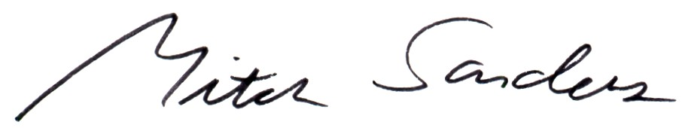

Mitch Sanders
Chairperson

Enclosures

