Citizens Coinage Advisory Committee | CCAC
801 Ninth Street, NW, Washington, DC 20220 | CCAC

June 28, 2006

The Honorable Henry M. Paulson, Jr.
Secretary of the Treasury
Department of the Treasury
1500 Pennsylvania Avenue, N.W.
Washington, D.C. 20220

Dear Secretary Snow:

A public meeting of the Citizens Coinage Advisory Committee was held on June 15, 2006, via teleconference. Attending the meeting were John Alexander, Bill Fivaz, Rita Laws, Mitch Sanders, Donald Scarinci, Ken Thomasma, Joe Winter, and Ute Wartenberg Kagan

The committee reviewed proposed designs for the San Francisco Old Mint commemorative coin program. Under this program, silver dollar coins and gold five-dollar coins are to be minted during the year 2006, with designs emblematic of the San Francisco Old Mint Building, its importance to California and the history of the United States, and its role in rebuilding San Francisco after the 1906 earthquake and fire.

For the obverse of the gold $5 coin, the CCAC recommends design GO-02, which is a replica of the “Coronet Head” $20 piece made from 1849 to 1907. The committee recommends that the design should be a replica of the original to the extent technologically possible, and that the accuracy of Liberty’s eye should be verified. The committee further recommends that the date should be presented as “1906 ~ 2006”.

The committee recommends design GR-01-B for the reverse of the gold $5 coin, with the following modifications: “CIRCA 1869” should be removed, and the wording “ARCHITECTURAL PLANS 1869” should be arranged in a curve under “SAN FRANCISCO OLD MINT.”

The CCAC recommends design SO-01, which is a replica of the “Morgan” dollar coin made from 1878 to 1921, for the obverse of the silver dollar. The committee recommends that the design should be a replica of the original to the extent technologically possible, and that the accuracy of Liberty’s eye should be verified. The committee further recommends that the date should be presented as “1906 ~ 2006”.

For the reverse of the silver dollar the CCAC recommends design SR-01-B. The CCAC also recommends that consideration should be given to incorporating “THE GRANITE LADY” in quotation marks into the reverse design.

The next CCAC meeting is scheduled for July 19, 2006.

Sincerely,

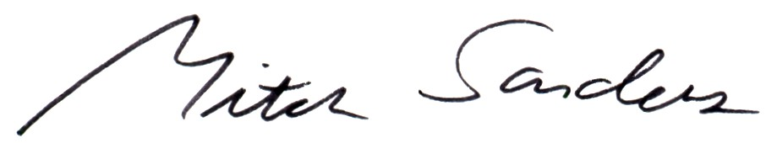

Mitch Sanders
Chair

