Citizens Coinage Advisory Committee | CCAC
801 Ninth Street, NW, Washington, DC 20220 | CCAC

June 5, 2006

Dear Secretary Snow:

A public meeting of the Citizens Coinage Advisory Committee was held on May 23, 2006 at United States Mint Headquarters in Washington, DC. Attending the meeting were John Alexander, Leon Billings, Bill Fivaz, Rita Laws, Mitch Sanders, Donald Scarinci, Ken Thomasma, and Joe Winter.

The committee viewed proposed designs for the 2007 issues of the First Spouses Gold Bullion Program. For the obverses, the CCAC recommends the following portraits:

Martha Washington: MW-O-05
Abigail Adams: AA-O-01
Liberty as represented on a coin issued during Thomas Jefferson’s Presidency: JL-O-04
Dolley Madison: DM-O-05

The committee recommends that the obverses of the Washington, Adams, and Madison issues should have inscriptions arranged as in design DM-O-02, with the following alterations: the positions of “Liberty / 2007” and “In God We Trust” should be reversed, and there should be a tilde (~) between the order of the Presidency and the dates of service.

For the reverses, the CCAC recommends the following designs:
MW-R-06: Martha Washington assisting a soldier in the Continental Army
(The CCAC recommends removing the horse and rider from MW-R-06.)
AA-R-05: Abigail Adams composing a letter and the quotation “Remember the Ladies”
JL-R-07: Thomas Jefferson’s grave and epitaph
DM-R-05: Dolley Madison helping the orphans of Washington, DC

The committee further recommends that the gold coins of the First Spouse bullion series should be produced in high relief to the extent practical, and that the bronze medallic versions should be in higher relief than the coin versions.

Images of the CCAC’s recommended designs are enclosed. Also enclosed are the minutes from the CCAC’s May 23 meeting, including details of the committee’s deliberations along with images of all designs evaluated.

The next CCAC meeting will be held on June 15, 2006.

Sincerely,

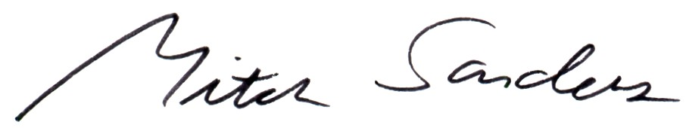

Mitch Sanders
Chair

