Citizens Coinage Advisory Committee | CCAC
801 Ninth Street, NW, Washington, DC 20220 | CCAC

March 16, 2006

The Honorable John W. Snow
Secretary
Department of the Treasury
1500 Pennsylvania Avenue, N.W.
Washington, D.C. 20220

Dear Secretary Snow:

A public meeting of the Citizens Coinage Advisory Committee was held on February 28, 2006 at United States Mint Headquarters in Washington, DC. Attending the meeting were John Alexander, Leon Billings, Bill Fivaz, Rita Laws (via telephone), Mitch Sanders, Donald Scarinci (via telephone), Ken Thomasma, S. Joseph Winter, and Ute Wartenberg Kagan.

Presidential $1 Coin Program

The Committee viewed proposed designs for the obverse and reverse of the 2007 Presidential dollar coins. Before the designs were presented, it was noted that the Committee appreciates the action taken by Acting Director David Lebryk and the staff of the United States Mint to solicit designs for the Presidential dollar coins from the Artistic Infusion Program.

There was general agreement that the portrait of the President should ideally be of the period of his presidency. All members with one exception also favored that the there should be a single template for the arrangement of the obverse inscriptions for the entire program, thus creating a consistency within the series. Everyone agreed that the President’s name should be shown as he was known in his own time.

For the coin honoring George Washington, most members liked portrait designs GW-08 and GW-12. GW-08 was narrowly preferred, with considerable support also for GW-12. Members generally thought highly of both designs, and both were considered suitable choices for the Washington coin. For the John Adams coin, the Committee preferred design JA-05. Members generally considered designs JA-05 and JA-07 preferable, in part because they represented Adams at the time of his Presidency. For the coin featuring Thomas Jefferson, the committee preferred design TJ-l0, which shows Jefferson in a three-quarter view and in simple dress. For the image of James Madison, the committee preferred design JM-08.

The Committee voted unanimously to recommend that for the Washington, Adams, Jefferson, and Madison designs, a three-quarter facing image should be preferred over a profile. The Committee further recommends that there should be a consistent arrangement of Presidents’ names, order of service, and dates of service throughout the duration of the Presidential dollar coin program. In particular, the Committee recommends the arrangement of lettering on design GW-03, with the President’s name at the top of the obverse, and the other required information at the bottom of the obverse below the portrait, presented as (for example) “1st President 1789-1797”. Members generally thought this arrangement was clearly expressed, and would fit with any Presidential portrait.

For the reverse of the Presidential dollar coin, which is to portray the Statue of Liberty, Committee members felt strongly that the statue’s torch should be visible. The Committee expressed a clear preference for design R-03. Committee members generally considered design R-03 to be a clear, complete, and accurate view of the statue, and appreciated the direct frontal perspective of the image.

The Committee discussed proposals for edge lettering around the coin, as required by the authorizing legislation. There was general agreement that a star should divide the different parts. The order of these parts was suggested to be “2007 * E PLURIBUS UNUM * IN GOD WE TRUST *”.

Jamestown 400 Anniversary

At its January 24, 2006 and February 28, 2006 meetings the Committee considered designs for the Jamestown 400 Anniversary Commemorative Coin. This program will consist of a gold $5 coin and a silver $1 coin, issued in 2007. For the obverse of the $5 gold coin the CCAC recommends design GO-02 featuring Captain John Smith and Chief Powhatan. For the reverse of the $5 gold coin the CCAC recommends design GR-07, featuring corn and a quotation from Chief Powhatan. For the silver obverse the committee preferred design S0-03, showing three faces of diversity, with the reference to “Founding” removed. For the silver reverse, the committee’s preference is design SR-02, featuring a Native American holding a bow and arrow.

The next CCAC meeting is scheduled for April 2006.

Sincerely,

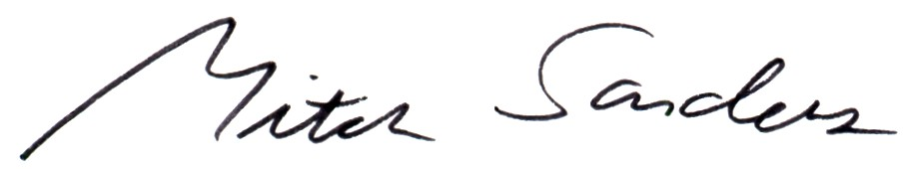

Mitch Sanders
Chair
Enclosures:
Committee Recommended Designs
Minutes and Design Options Considered at the February 28, 2006 Meeting
Designs Evaluated by the Committee

