Citizens Coinage Advisory Committee | C CAC
801 Ninth Street, NW, Washington, DC 20220 | C CAC

February 15, 2006

The Honorable John W. Snow
Secretary
Department of the Treasury
1500 Pennsylvania Avenue, N.W.
Washington, D.C. 20220

Dear Secretary Snow:

A public meeting of the Citizens Coinage Advisory Committee was held on January 24, 2006 at United States Mint Headquarters in Washington, DC. Attending the meeting were John Alexander, Leon Billings, Bill Fivaz, Rita Laws (via telephone), Mitch Sanders, Donald Scarinci, Ken Thomasma, S. Joseph Winter, and Ute Wartenberg Kagan.

State Quarter Program

The committee reviewed proposed designs for the Montana, Washington, Idaho, Wyoming, and Utah state quarters. These coins will be released in the year 2007.

For Montana the committee’s preference was design MT-2, “Bison Skull.” Members recognized the power of this symbol in the state’s history, and thought that this design most captured the state. Members also thought that the large image would translate well onto a quarter coin.

For Washington’s quarter the committee preferred design WA-2, “A salmon breaching the water with Mount Rainier as a backdrop.” Members strongly endorsed this theme, which was seen as attractive and significant for the state. It was suggested to remove the drops of splashing water, and perhaps to replace the small waves with a few simple lines to indicate the water’s surface. Some members expressed concern about the accuracy of the salmon’s appearance.

Two designs were tied as the committee’s most preferred for the Idaho quarter: ID-1, “Peregrine Falcon,” and ID-2, “Sawtooth Mountains.” Members liked the strong design of the falcon head on ID-1, but felt strongly that the state outline detracted from the overall design. Most members felt that the state outline should be removed, and two members felt that it should at least be reduced in size. It was also noted that the star indicating the location of the capital Boise was unnecessary and probably unrecognizable in reduced size on the quarter. It was requested that the design of the bird and outline, if chosen, should be more balanced and leave less space of the right side of the field. Regarding design ID-2, it was questioned whether the mountainous landscape was representative of the agricultural state of Idaho. However, most members expressed admiration for a clever incorporation of the state outline.

Regarding the Wyoming quarter, members felt that the bucking horse and rider theme was emblematic of the state. The committee’s recommended rendition is design WY-4, “Bucking Horse and Rider, in a typical Wyoming scene.” Overall, this theme –though conventional – was seen as authentic and successful.

For Utah the committee recommends design UT-1, “Golden Spike/Locomotive.” Some members thought that the depiction of a historical event deserved support. However others thought that the depiction of the event was perhaps not clear enough and that the subject was too complex for a depiction on the quarter. There was some criticism of the details of the locomotives, which were not viewed as historically accurate. It was suggested that if this design were adopted, the words “TRANSCONTINENTAL RAILROAD” should appear beneath the scene, and the date and location of the event should also be indicated in the coin’s design.

Presidential Dollar Coin

The committee also evaluated proposed designs for the Presidential dollar coin, to be issued beginning in 2007. Six templates, all based on the United States Mint’s Presidential medal series, were presented. It was intended by the Mint that a single template should be used throughout the Presidential dollar series. Most members believed that design 3, with its clear lettering, large portraits, and more modern look, was most acceptable of the alternatives presented.

However, all members considered the portraits to be uninspired design choices. It was unanimously decided to recommend that the United States Mint should reconsider the design process by obtaining new images with the help of the Artistic Infusion Program. It was the sense of the committee that the opportunity to make the Presidents of the past accessible to the generations of the 21st century should not be missed, and that a program of such importance would benefit from additional consideration of designs in the interest of presenting the best possible artwork.

Jamestown 400th Anniversary

The committee then considered designs for the Jamestown 400th Anniversary Commemorative Coin. This program will consist of a gold $5 coin and a silver $1 coin, issued in 2007. For the obverse of the $5 gold coin the CCAC recommends design GO-02 featuring Captain John Smith and Chief Powhatan. For the reverse of the $5 gold coin the CCAC recommends design GR-09, featuring a Native American woman carrying corn, with the inscription “A Gift From Our Harvest” removed. For the silver obverse the committee preferred design SO-03, showing three faces of diversity, with the reference to “Founding” removed. For the silver reverse, the committee’s preference is design SR-02, featuring a Native American holding a bow and arrow.

Buffalo 24-Karat Gold Bullion Coin

Finally, the committee considered designs for the Buffalo 24-Karat Gold Bullion Coin. The CCAC voted unanimously to recommend obverse 24K-GO-5, which exactly duplicates Fraser’s original 1913 design, for the coin’s obverse, and 24K-GR-1 for the reverse. The committee also recommends that the Buffalo Gold Bullion Coin should have the same textured fields as on the original “Type 1” nickel design of 1913, for both the proof and the uncirculated version. Committee members expressed considerable enthusiasm for this program, considering it to be a success both conceptually and artistically.

The next CCAC meeting will be held at United States Mint headquarters in Washington, DC on Thursday, February 28, 2006.

Sincerely,

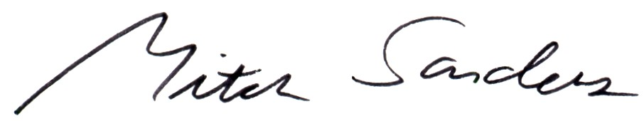

Mitch Sanders
Chair

Enclosures:
CCAC Recommended Designs
Minutes of January 24, 2006 CCAC meeting
Designs evaluated by the CCAC

