October 11, 2005

The Honorable John W. Snow
Secretary
Department of the Treasury
Washington, DC 20220

Dear Secretary Snow:

A public meeting of the Citizens Coinage Advisory Committee (CCAC) was held on September 27, 2005, at United States Mint headquarters in Washington, DC. In attendance were Mitch Sanders (Vice-Chair), Ute Wartenberg (Secretary), Daniel Altshuler, Leon Billings, Bill Fivaz, Connie Harriman, Rita Laws, and Ken Thomasma.

The CCAC considered proposed designs for the Dr. Martin Luther King and Coretta Scott King Congressional Gold Medal. Public Law 108-368 authorizes the President “to award a gold medal on behalf of the Congress to Reverend Doctor Martin Luther King, Jr. (posthumously) and his widow Coretta Scott King in recognition of their contributions to the Nation on behalf of the civil rights movement.”

The CCAC voted unanimously to recommend the proposed obverse design. However, it was suggested that the image of Dr. King’s shoulder, as currently drawn, detracts from the overall design.

For the reverse of the medal, the CCAC voted unanimously not to recommend the proposed design, which features an image of the Martin Luther King, Jr. Center for Nonviolent Social Change, along with two quotations from Dr. King. Members suggested that a symbolic representation, with a shorter and more familiar quotation, would have been a more powerful design. Members also felt that the fountains in the forefront of the design detract from the image of the building.

The members also considered the CCAC Annual Report for 2005, as required by Public Law 108-15. The report will be completed for submission by November 30, 2005.

The next CCAC meeting will be held on November 15, 2005.

Sincerely,

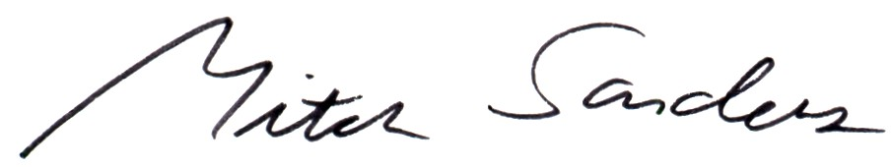

Mitch Sanders
Vice-Chair

