Dear Secretary Snow:

A public meeting of the Citizens Coinage Advisory Committee was held on Thursday, July 28, 2005. This meeting was conducted at the annual meeting of the American Numismatic Association in San Francisco, CA. Attending the meeting were Mitch Sanders (Vice-Chair), Ute Wartenberg (Secretary), Daniel Altshuler (via telephone), Leon Billings (via telephone), Bill Fivaz, Rita Laws, Donald Scarinci, and Ken Thomasma.

Public Law 108-15 provides that the CCAC shall, among other duties, advise the Secretary of the Treasury “on any theme or design proposals relating to circulating coinage, bullion coinage, congressional gold medals and national and other medals.” In fulfillment of that provision, the CCAC considered proposed designs for the reverse of the American Eagle Platinum proof bullion coins, for the years 2006, 2007, and 2008. This series of coins will represent the three branches of the United States Government: Legislative, Executive, and Judicial.

For the 2006 issue representing the Legislative branch, the committee recommends design L-6. Members praised L-6 as a very nice and very interesting design, and an appropriate allegorical representation of the Legislative Branch of government. It was recommended that the design be clarified to show that the figure’s eyes are open.

The committee recommends design E-3 for the Executive branch issue of 2007. Members appreciated the contemporary meaning of the design, the strength of the eagle, and the inscription “Freedom” on design E-3. There was a consensus that on design E-3 the banner draped over the shield should appear to be flowing and less rigid, and that the typeface on the word “Freedom” should be changed.

Among the designs for the Judicial branch, scheduled for issue in 2008, the committee recommends design J-1. Members considered design J-1 to be dramatic, beautifully done, and symbolic. Members also thought that the combination of two powerful figures on design J-1 – the American eagle and the owl representing wisdom – was interesting and innovative, and would work very well on a coin. There was a consensus that whichever design was chosen, the figure of Justice should be blindfolded.

Images of the CCAC’s recommended designs are attached. Also enclosed are the minutes of the CCAC’s July 28 meeting, containing details of the committee’s deliberations along with images of all designs evaluated.

The next CCAC meeting will be held on September 27, 2005 at the United States Mint headquarters in Washington, DC.

Sincerely,

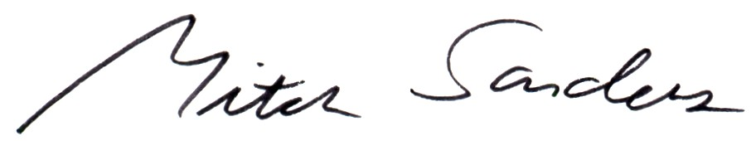

Mitch Sanders
Vice-Chair

